U23IT484 – CLOUD COMPUTING TECHNOLOGIES

Name: Yogeshwaran K
Roll No: 24AM123

ROUND 2 (i) – IMPLEMENT AWS STORAGE
Objective
To implement secure cloud storage using Amazon S3 with encryption, versioning, access control, and protection against accidental or unauthorized data deletion.
Procedure
Step 1 – Open Amazon S3
- Sign in to the AWS Management Console.
- Search for S3 and open the Amazon S3 service.
- Navigate to Buckets and select Create bucket.
- Enter a globally unique bucket name.
- Select the required AWS Region.
- Keep Block all public access enabled.
- Create the bucket.
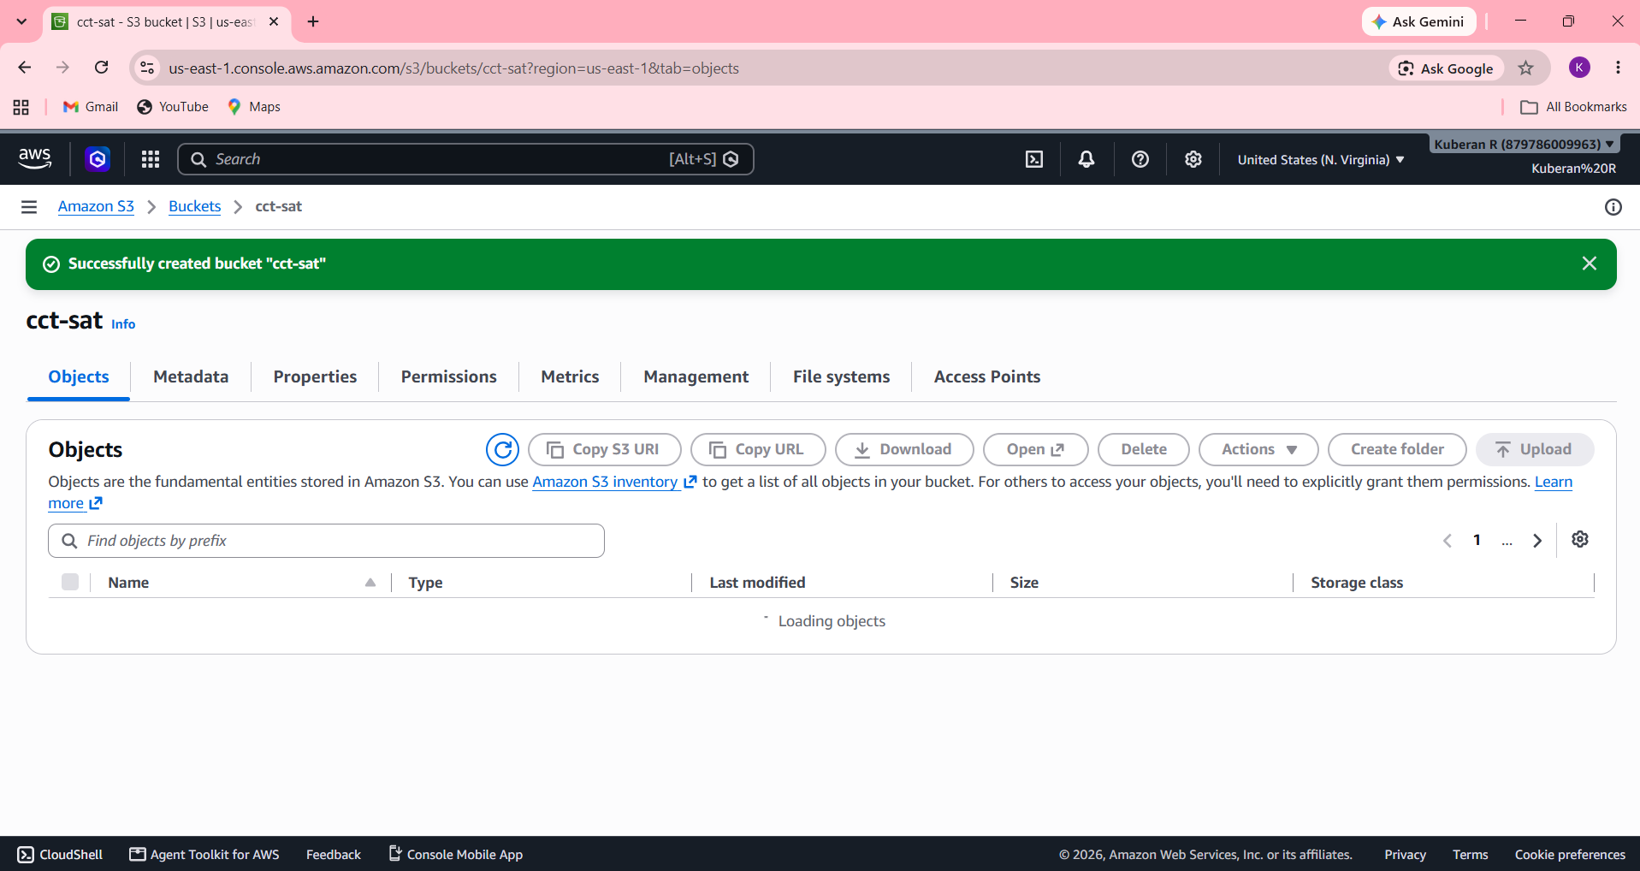

Step 2 – Enable S3 Versioning
- Open the newly created S3 bucket.
- Go to the Properties tab.
- Find Bucket Versioning.
- Select Enable.
- Save the configuration.
Versioning helps retain previous versions of objects and provides recovery from accidental overwrites or deletions.
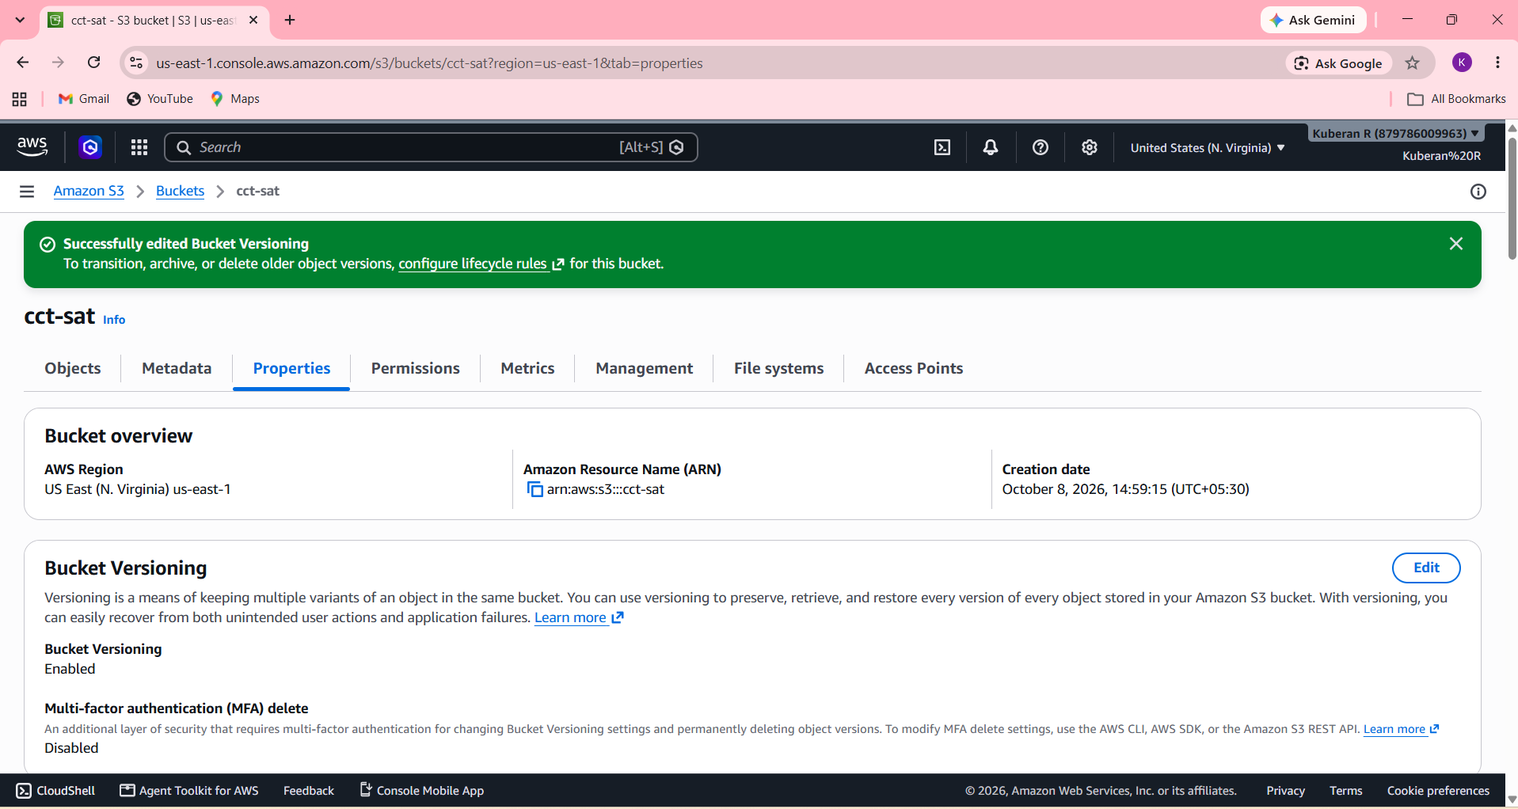

Step 3 – Configure Server-Side Encryption
- In the S3 bucket, open the Properties tab.
- Locate Default encryption.
- Enable server-side encryption.
- Select SSE-S3 for a simple student implementation.
- Save the configuration.
This ensures that objects stored in the bucket are encrypted at rest.
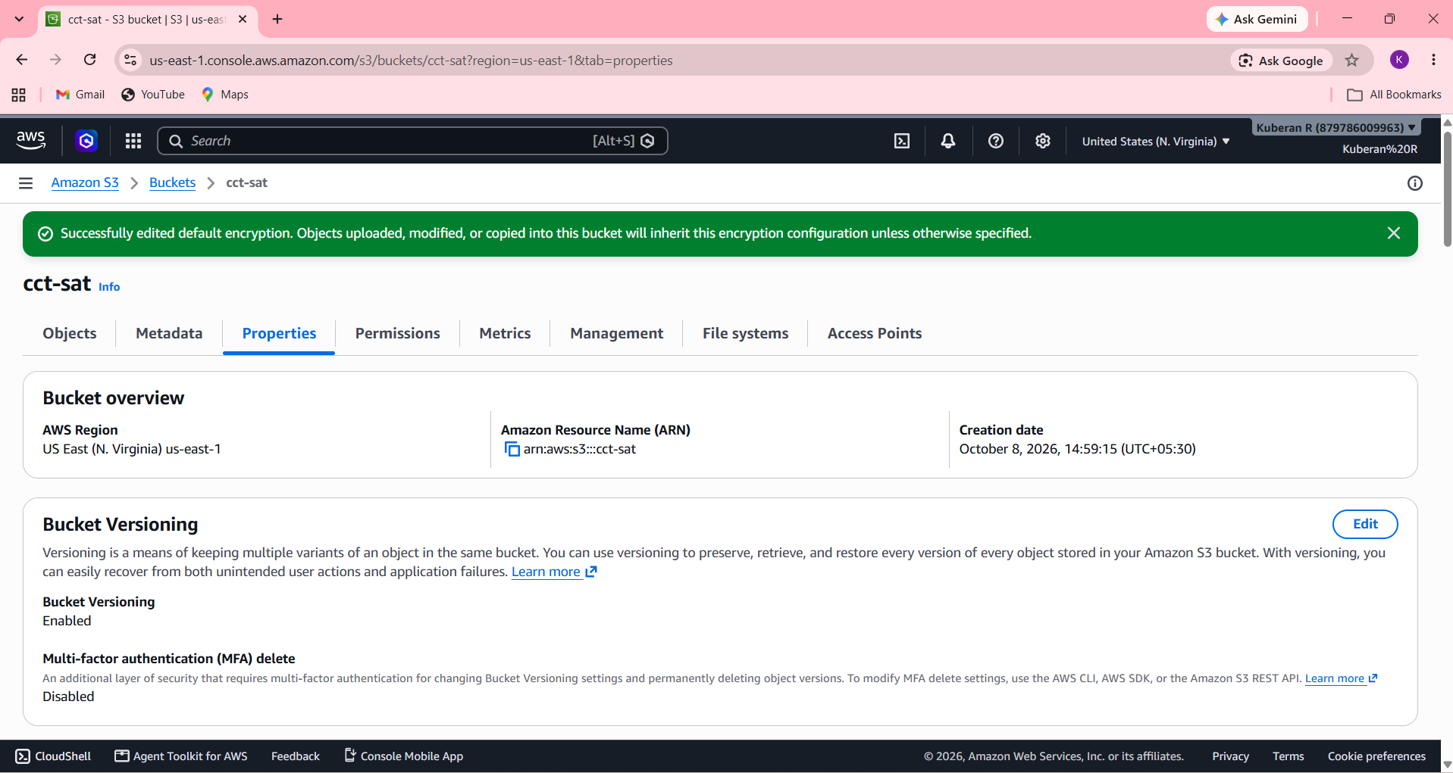

Step 4 – Configure Public Access Protection
- Open the bucket's Permissions tab.
- Verify that Block all public access is enabled.
- Confirm that no public bucket policy is configured.
- Save the settings if any changes were made.
This prevents the storage bucket from accidentally becoming publicly accessible.
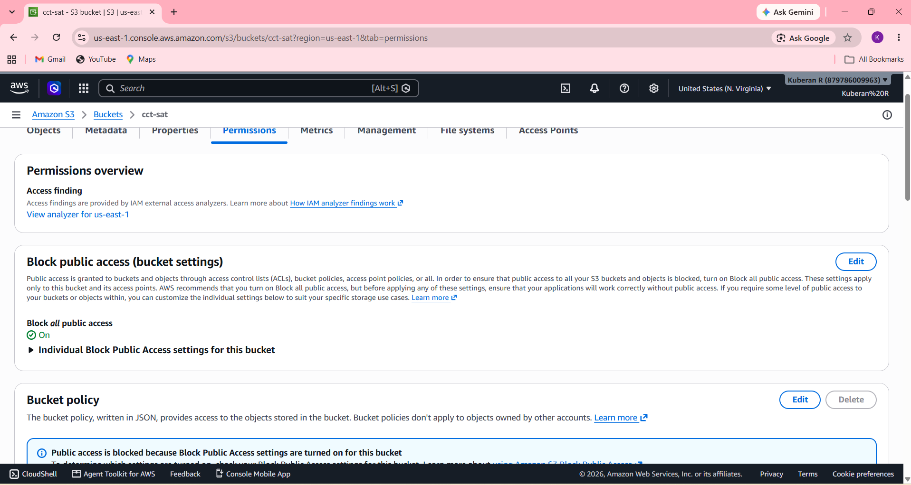

Step 5 – Upload a Test Object
- Open the S3 bucket.
- Select Objects → Upload.
- Upload a small test file.
- Verify that the object appears in the bucket.
- Open the object's Properties and verify its encryption/version information.
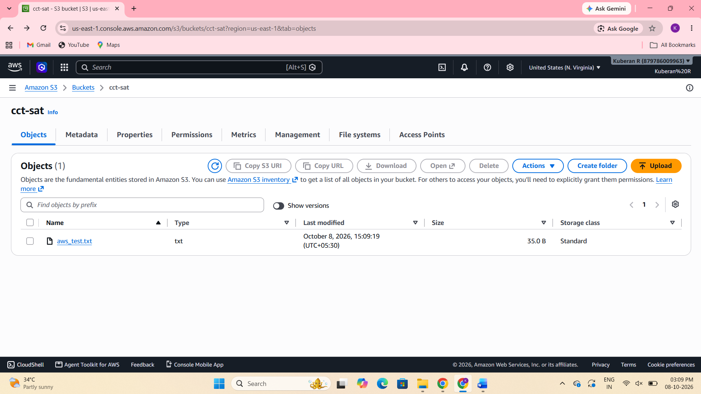

Step 7 – Test Versioning
- Upload a file with the same name again after modifying its contents.
- Open the bucket and enable Show versions.
- Verify that multiple versions of the object are available.
This demonstrates how S3 versioning can help recover previous data.
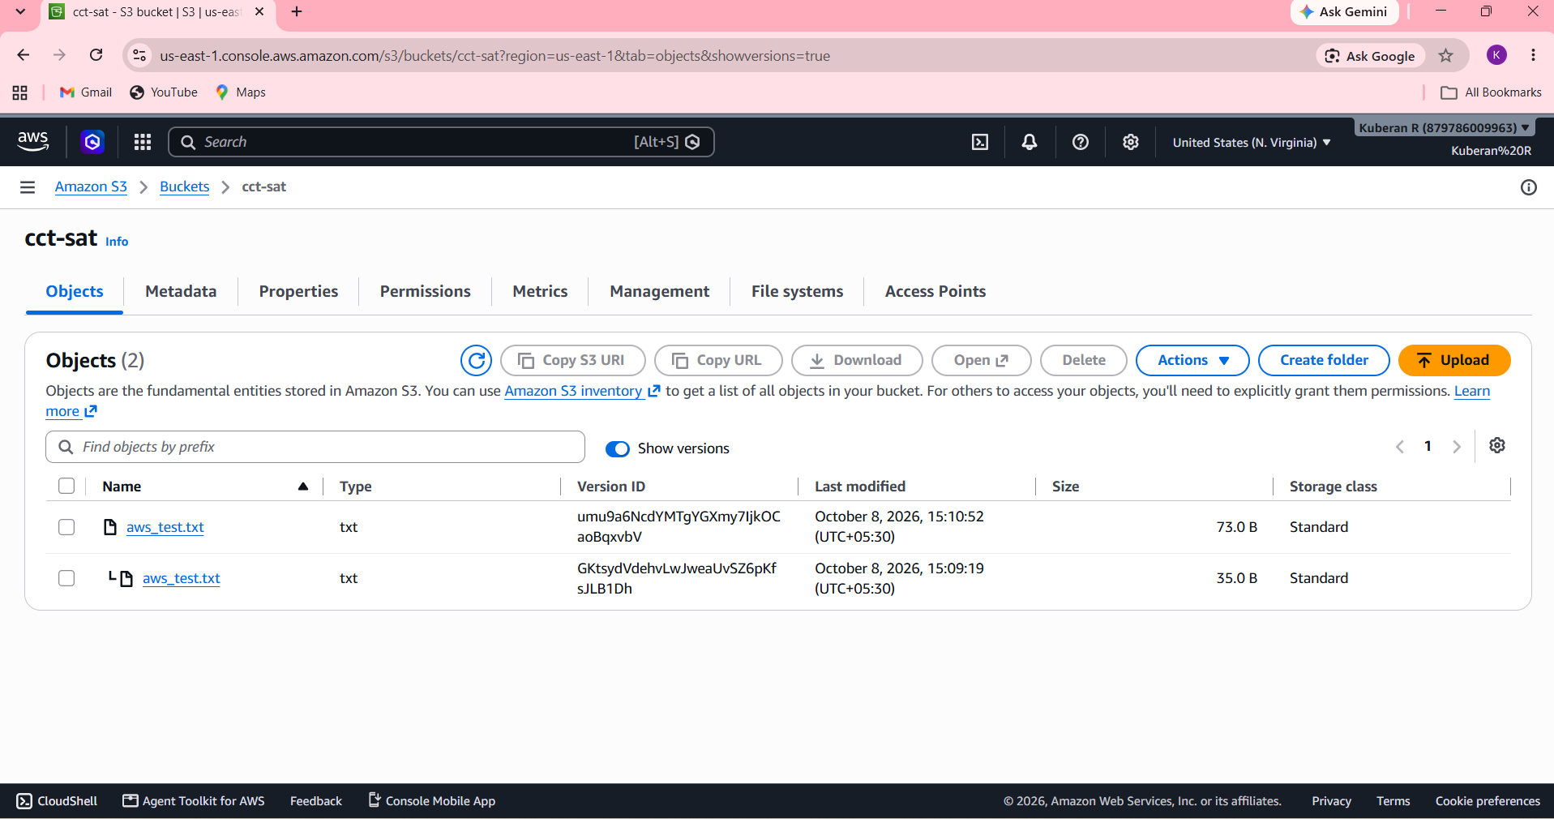

ROUND 2 (ii) – BUILD END-TO-END AWS SOLUTION
Objective
To build an end-to-end AWS cloud solution by integrating VPC, EC2, RDS, S3, IAM, and security controls to provide a secure and functional application environment.
Procedure
Step 1 – Create the VPC
- Open AWS Console → VPC.
- Select Create VPC.
- Choose VPC only.
- Give the VPC a suitable name, such as Secure-Production-VPC.
- Use a private CIDR range such as:
10.0.0.0/16
- Create the VPC.
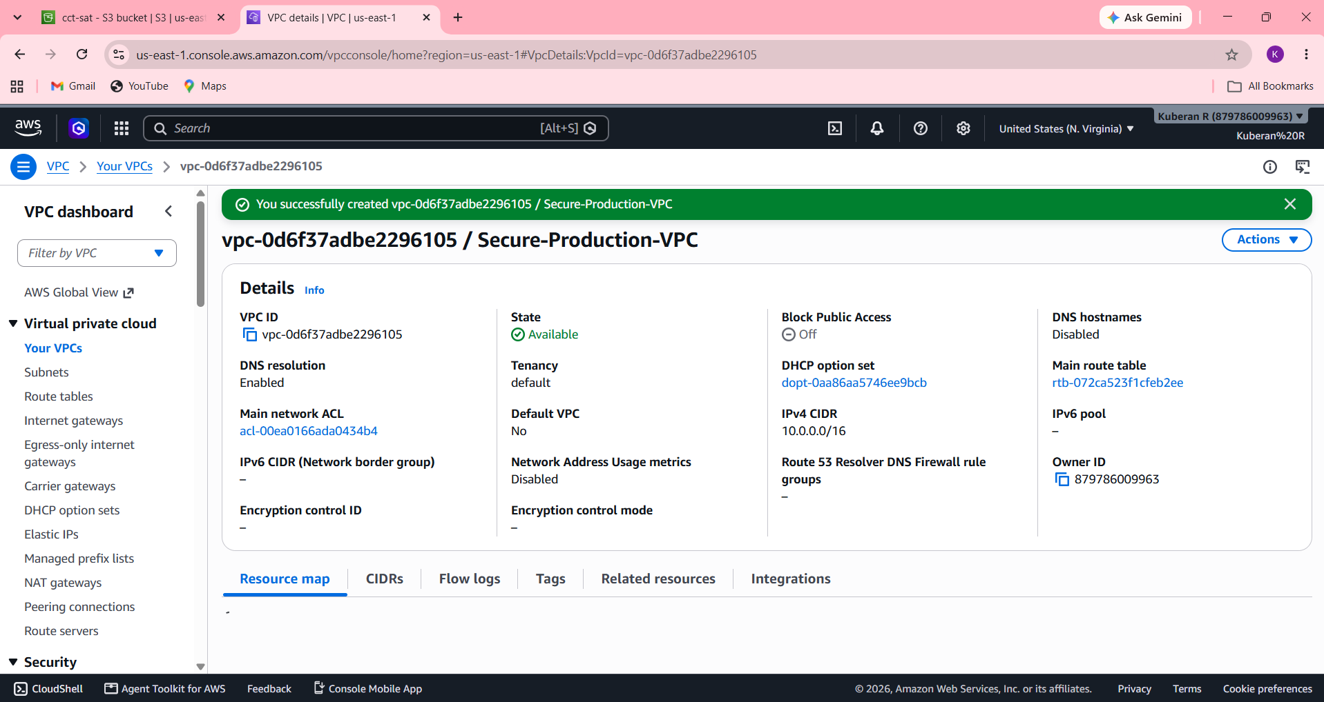

Step 2 – Create the Subnets
Create separate subnets for the application and database components.
For example:
VPC: 10.0.0.0/16
Public Subnet:
10.0.1.0/24
Private Subnet:
10.0.2.0/24
- Open VPC → Subnets.
- Create the public subnet.
- Create the private subnet.
- Associate both with the production VPC.
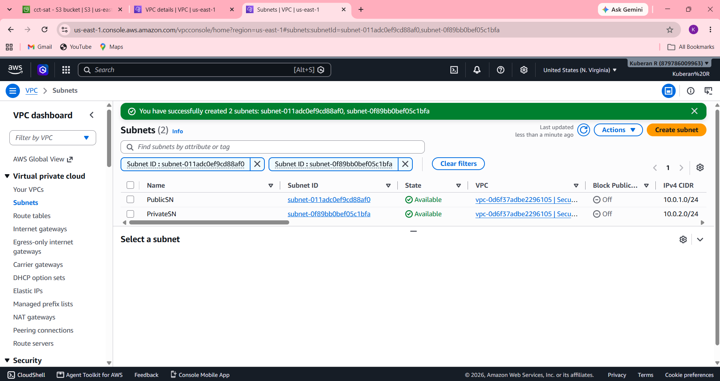

Step 3 – Configure Internet Connectivity
For the EC2 application server to receive required internet connectivity:
- Create an Internet Gateway.
- Attach it to the VPC.
- Create/configure a route table for the public subnet.
- Add the route:
0.0.0.0/0 → Internet Gateway
- Associate the route table with the public subnet.
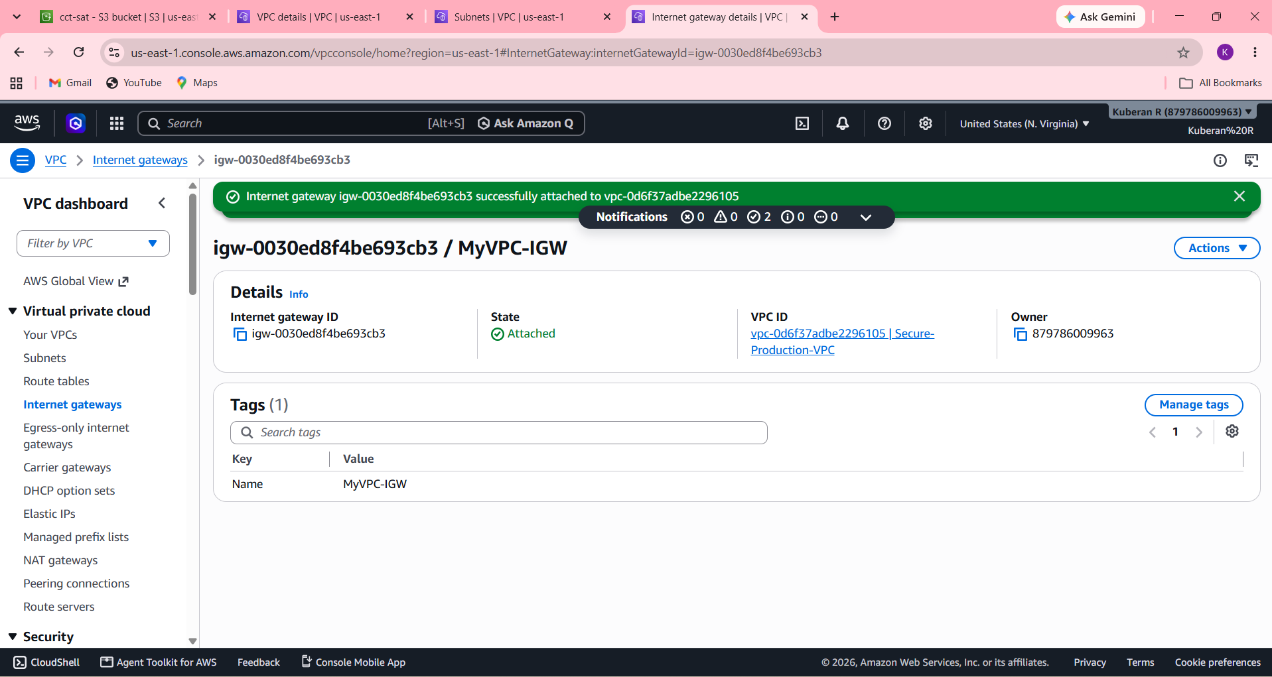
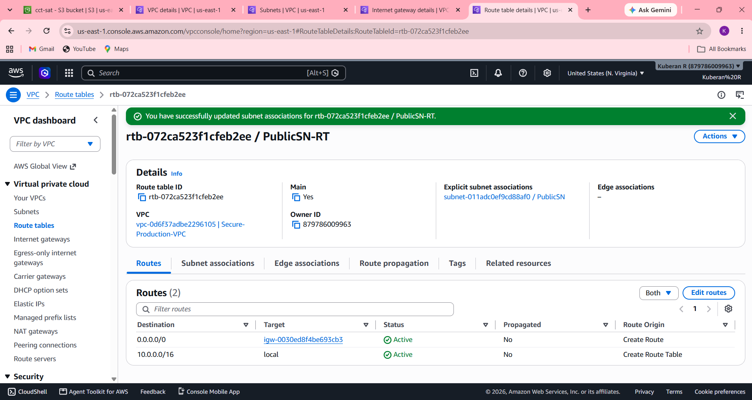

Step 4 – Create Security Groups
Create separate security groups for EC2 and RDS.
EC2 Security Group
Allow only the required application traffic.
For example:
SSH → Your IP only
HTTP → Required source
HTTPS → Required source
RDS Security Group
Do not allow database access from the entire internet.
Instead:
MySQL 3306 → EC2 Security Group
This means only the EC2 application server can communicate with the database.
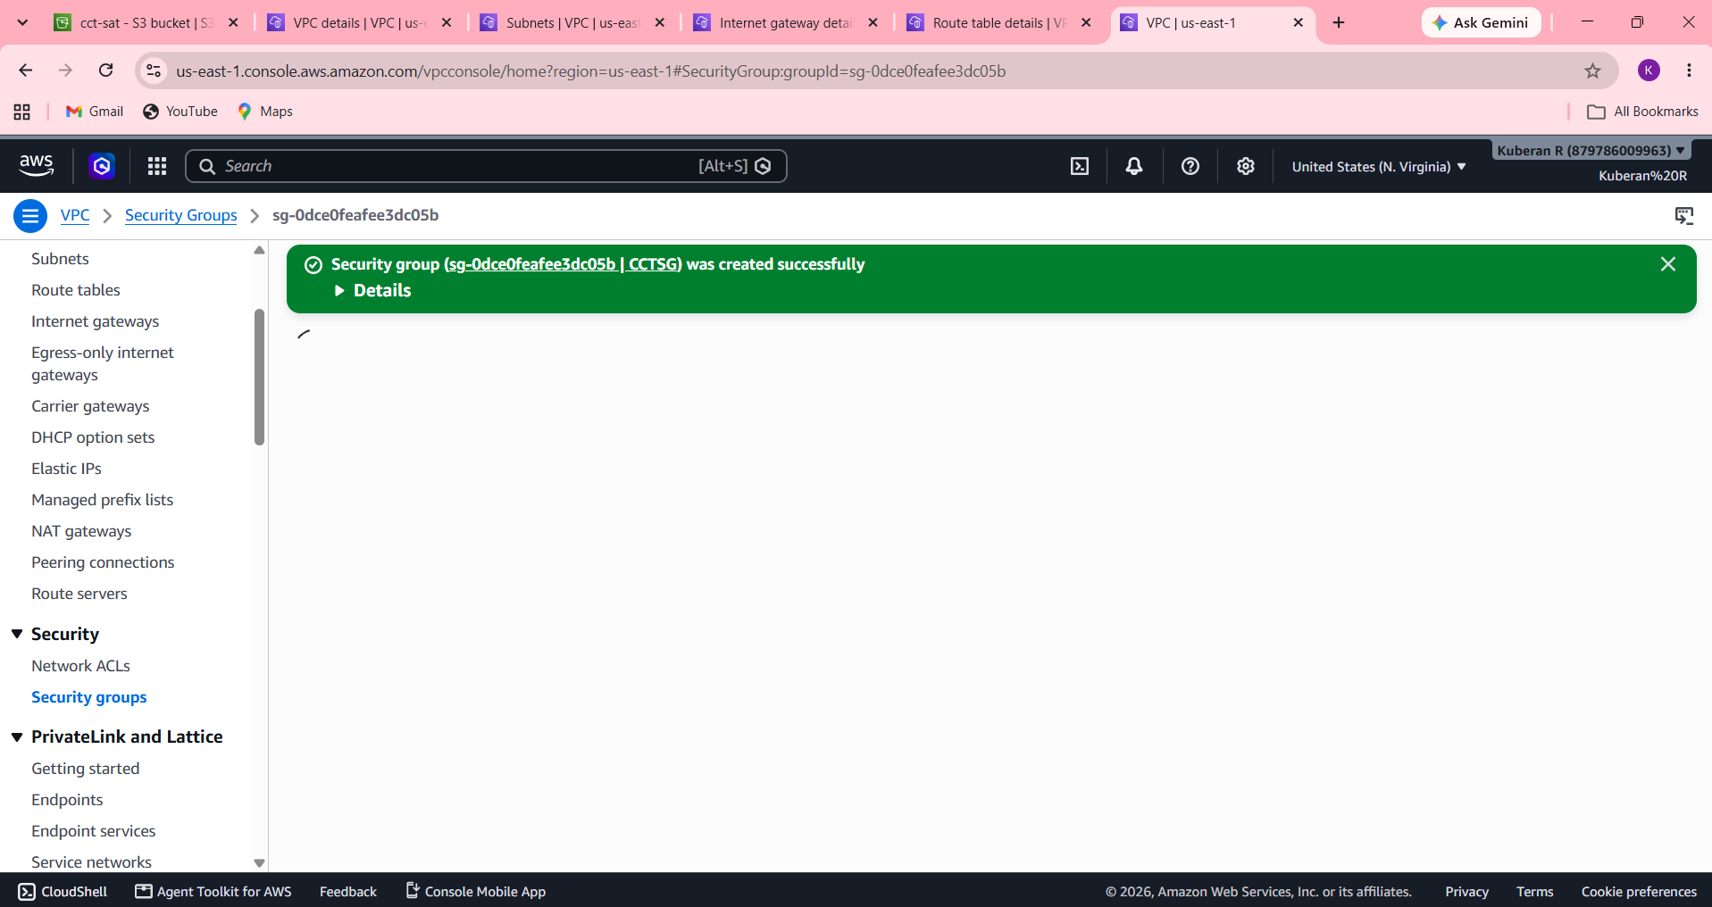
Step 5 – Launch the EC2 Instance
- Open EC2 → Instances.
- Select Launch Instance.
- Give it a name such as:
Production-App-Server
- Select an appropriate free-tier-eligible AMI/instance type if available to you.
- Select the previously created VPC.
- Select the public subnet.
- Enable a public IP only if required for your implementation.
- Select the EC2 security group created earlier.
- Launch the instance.
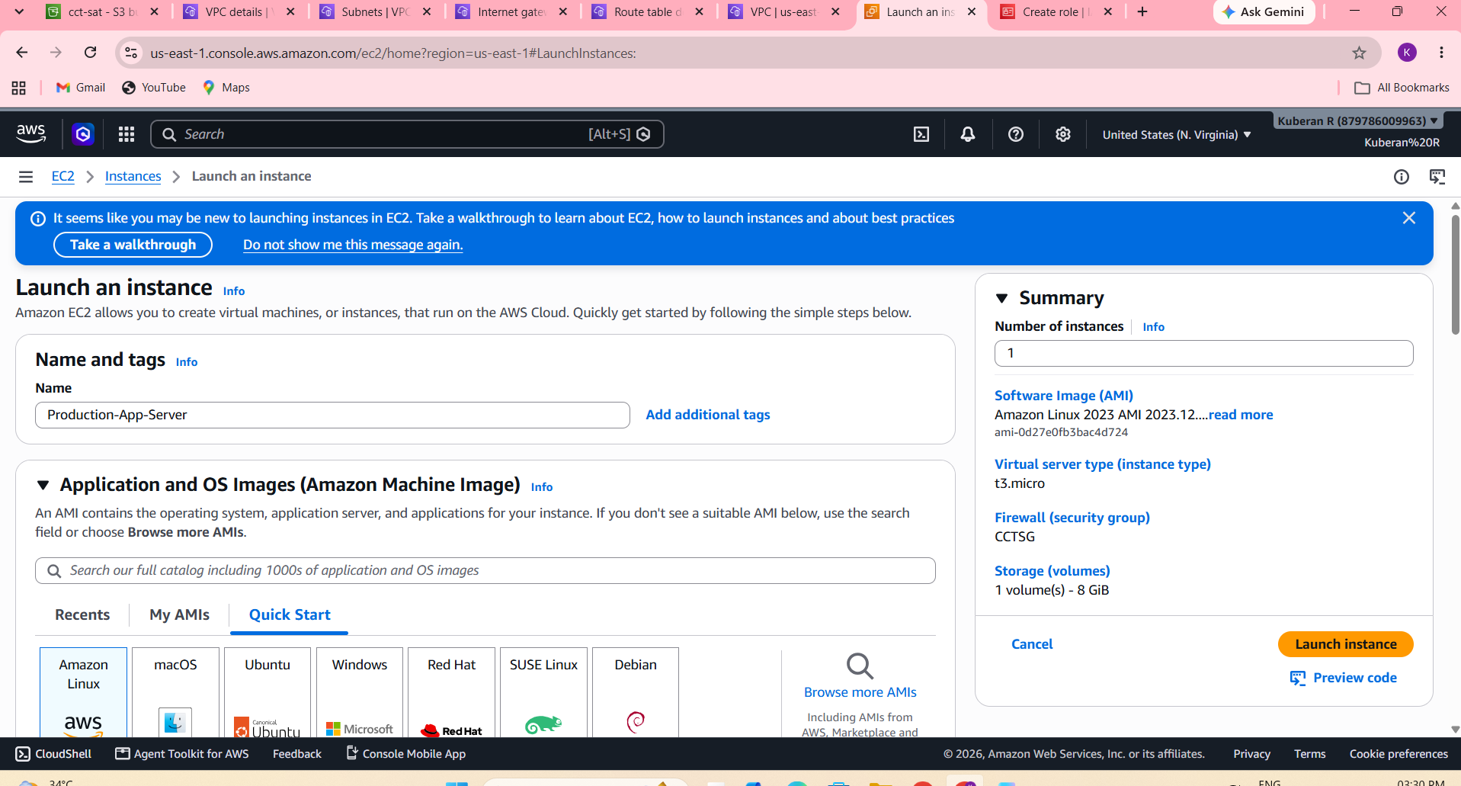

Step 6 – Create an IAM Role for EC2
Instead of storing AWS access keys inside the EC2 machine:
- Open IAM → Roles.
- Create a role for EC2.
- Attach a restricted S3 policy.
- Allow only the required S3 actions.
- Attach the role to the EC2 instance.
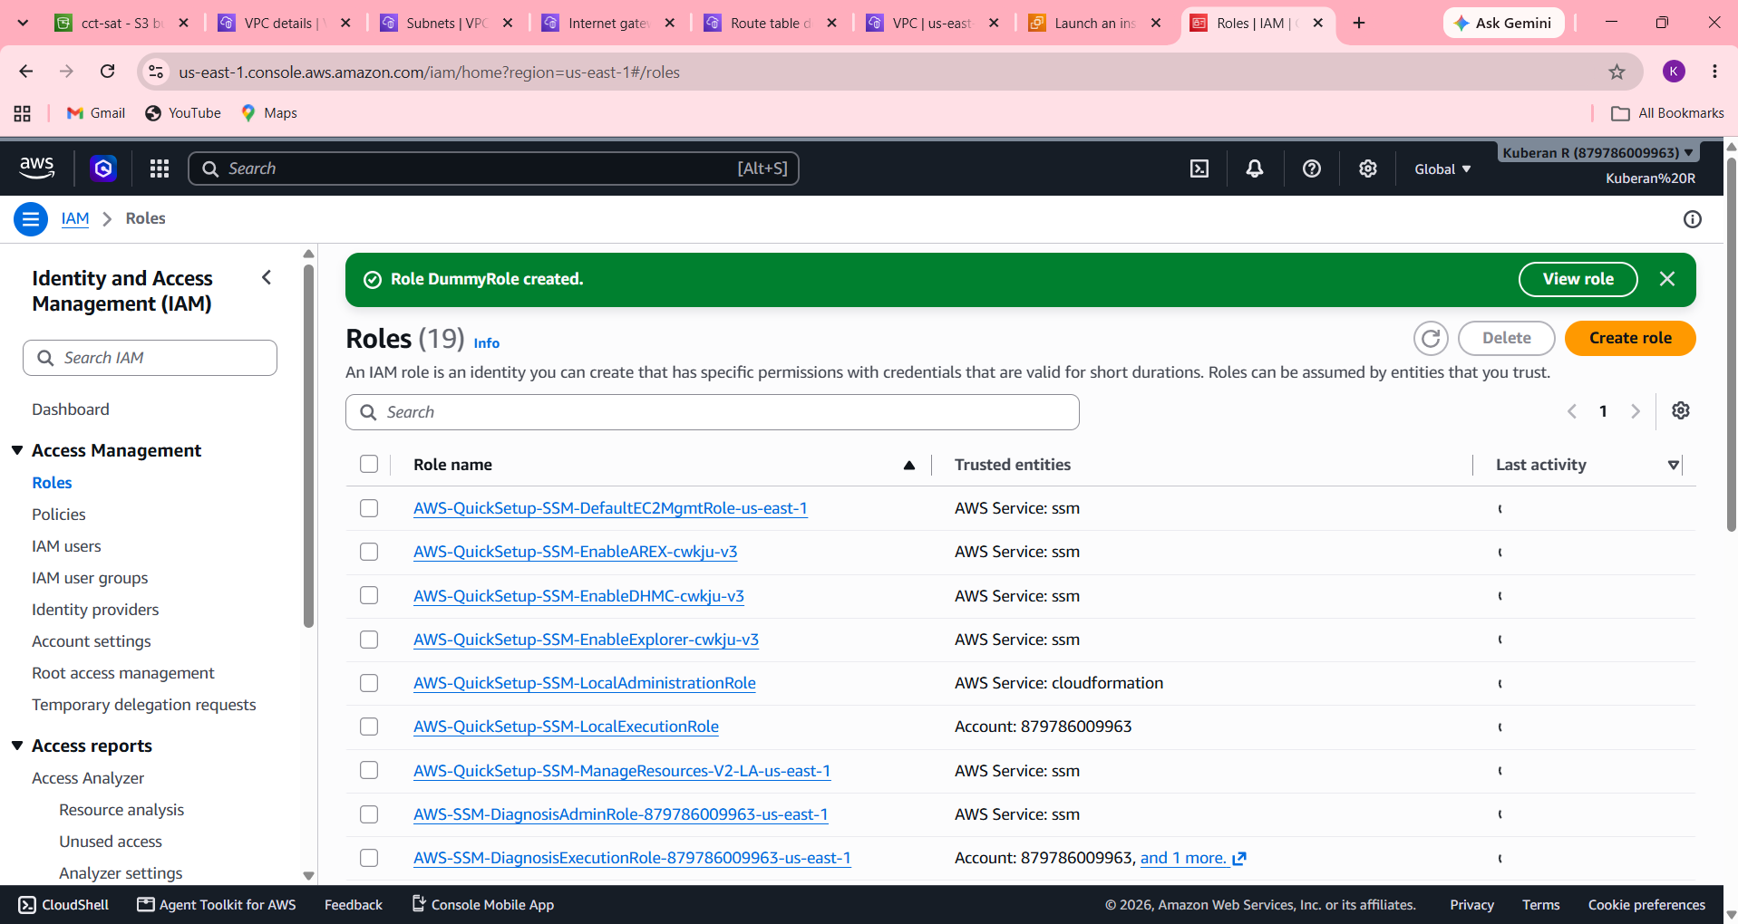
ROUND 3 – DATA INTEGRATION AND DEPLOYMENT
Objective
To integrate application data with AWS services and deploy the application using EC2, RDS, and S3, while validating secure communication, data access, monitoring, and deployment.

Step 1 – Upload Application Data to S3
- Open the S3 bucket created in Round 2.
- Create a suitable folder/prefix for application data if required.
- Upload the required dataset/files.
- Verify that the objects are encrypted and versioned.
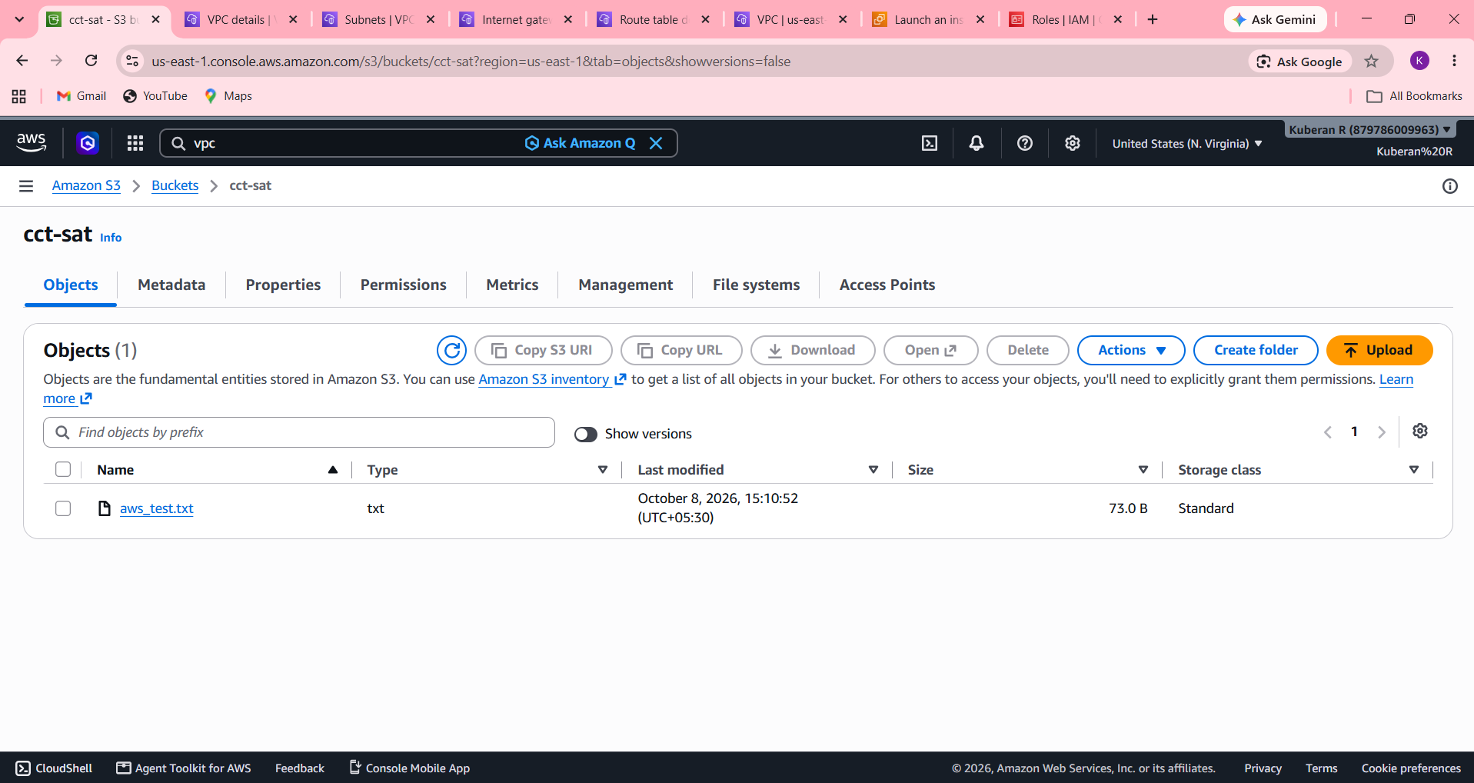

Step 2 – Configure the RDS Database
- Open the RDS database created in Round 2.
- Connect to the database from the EC2 instance.
- Create the required database/table structure.
- Insert sample application data.
- Verify that the data can be retrieved successfully.
